Document on k8-cluster deployment commands

- Get into the killercoda site and perform the commands.
- Start with sudo su command to become as a root use

Cmd: sudo su 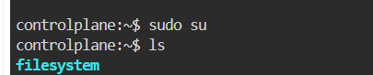

- Then create a namespace

Cmd: kubectl create ns t20wc-ns (this cmd is used to create the name-space )

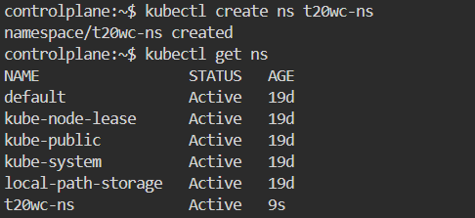

- Then create a directory

Cmd: mkdir <name> (this cmd is used to create a new directory)

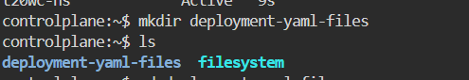

- After creating the directory go into the directory

Cmd : cd <name> (this cmd is used to enter into the selected directory)

- In that directory create a file name it

Cmd: vi t20wc-dep.yaml(this cmd is used to enter into the file so that we can add the yaml file in it)

- Then paste the deployment code in the file

apiVersion: apps/v1
kind: Deployment
metadata:
name: t20-dep
namespace: t20wc-ns
spec:
replicas: 3
selector:
matchLabels:
app: t20-app
template:
metadata:
labels:
app: t20-app
spec:
containers:
- name: t20-container
image: nginx:latest
ports:
- containerPort: 80

- Now apply the deployment file to run other process

Cmd: kubectl apply -f t20wc-dep.yaml(this cmd is used to run what all the data presented in the yaml file)

9. To check all the pods

Cmd: kubectl get all -n t20wc-ns (this cmd is used to check all the running pods.)

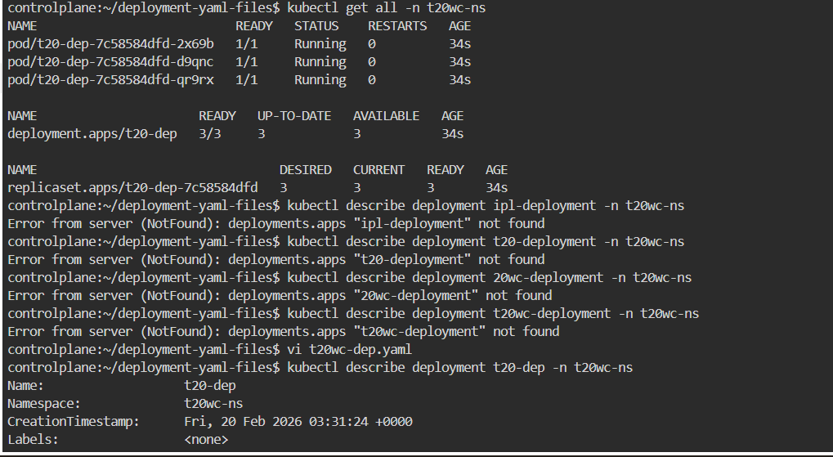

10. Now It shows complete details about the deployment.

Cmd : kubectl describe deployment t20-deployment -n t20wc-ns

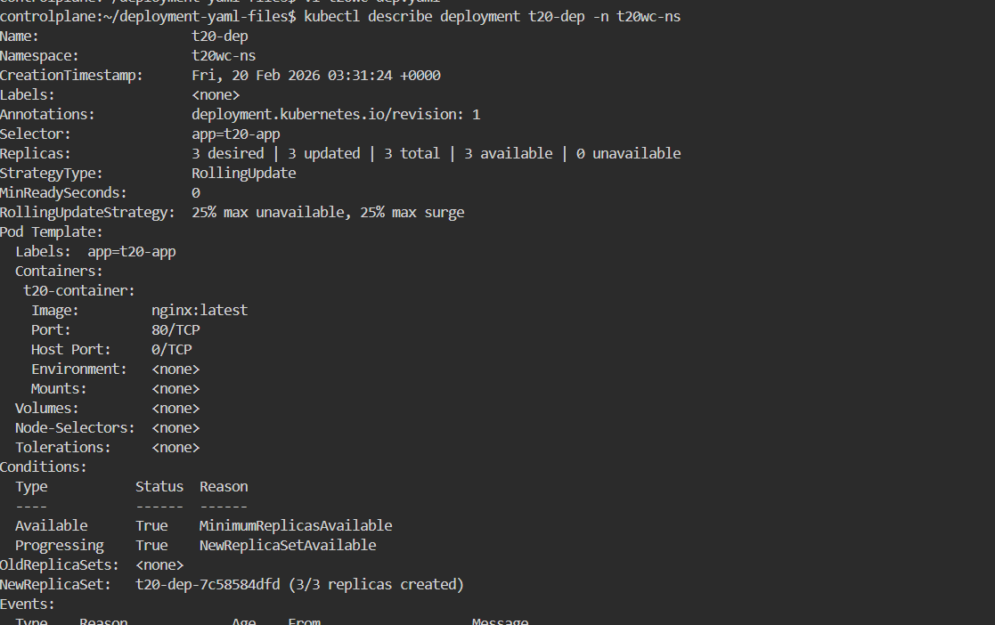

11. After completing the cmd now just copy the pod number and check with the command

Cmd: kubectl describe pod t20-dep-6f4df56686-pkrnx -n t20wc-ns

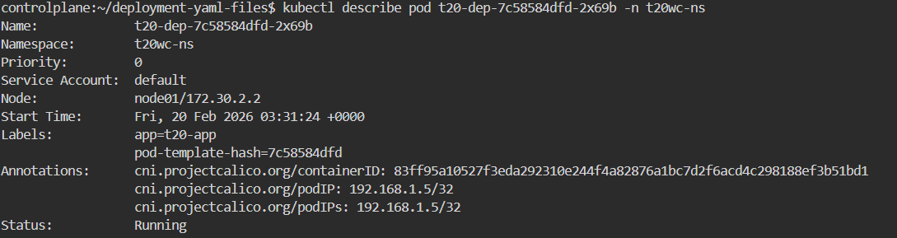

12. It checks and shows the real-time status of the deployment update (whether the rollout is successfully completed or still in progress).

Cmd: kubectl rollout status deployment t20-dep -n t20wc-ns

13. It rolls back the deployment to the previous working version if the current update has issues.

Cmd : kubectl rollout undo deployment t20-dep -n <namespace>

